Special Numbers
# Source: AI Source: Provided by: [Data Path: Persons Table -> ID Column: 1, Name_En Column: Motasem Essam] -> From: [ChatGPT] on [7/11/2026]
Special Numbers are numbers that possess unique mathematical properties or characteristics that distinguish them from ordinary numbers. These numbers play important roles in arithmetic, algebra, number theory, geometry, combinatorics, computer science, cryptography, and many other branches of mathematics.
Special numbers may be defined by their structure, divisibility, digit patterns, algebraic properties, or relationships with other numbers.

Definition
# Source: AI Source: Provided by: [Data Path: Persons Table -> ID Column: 1, Name_En Column: Motasem Essam] -> From: [ChatGPT] on [7/11/2026]
A Special Number is a number that satisfies one or more unique mathematical properties or belongs to a recognized mathematical classification.
Unlike general number types (such as integers or rational numbers), special numbers are identified by specific patterns or behaviors.

Common Types of Special Numbers
# Source: AI Source: Provided by: [Data Path: Persons Table -> ID Column: 1, Name_En Column: Motasem Essam] -> From: [ChatGPT] on [7/11/2026]
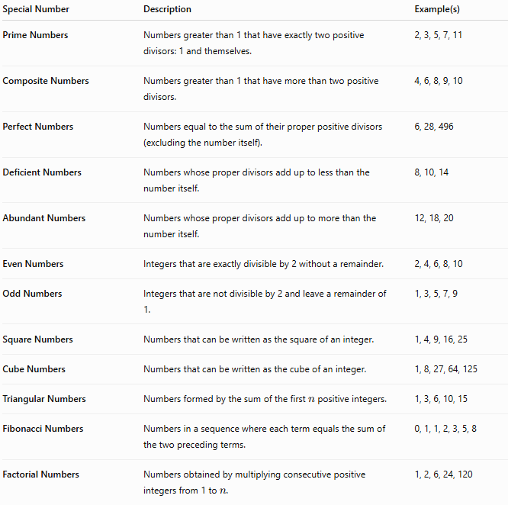
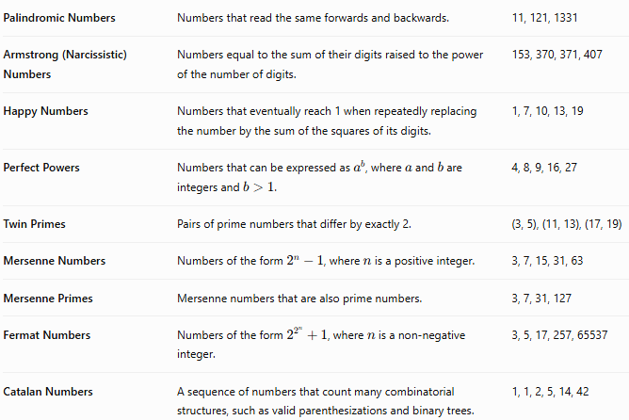
Special Number | Description | Example(s)
Prime Numbers | Numbers greater than 1 that have exactly two positive divisors: 1 and themselves. | 2, 3, 5, 7, 11
Composite Numbers | Numbers greater than 1 that have more than two positive divisors. | 4, 6, 8, 9, 10
Perfect Numbers | Numbers equal to the sum of their proper positive divisors (excluding the number itself). | 6, 28, 496
Deficient Numbers | Numbers whose proper divisors add up to less than the number itself. | 8, 10, 14
Abundant Numbers | Numbers whose proper divisors add up to more than the number itself. | 12, 18, 20
Even Numbers | Integers that are exactly divisible by 2 without a remainder. | 2, 4, 6, 8, 10
Odd Numbers | Integers that are not divisible by 2 and leave a remainder of 1. | 1, 3, 5, 7, 9
Square Numbers | Numbers that can be written as the square of an integer. | 1, 4, 9, 16, 25
Cube Numbers | Numbers that can be written as the cube of an integer. | 1, 8, 27, 64, 125
Triangular Numbers | Numbers formed by the sum of the first $n$ positive integers. | 1, 3, 6, 10, 15
Fibonacci Numbers | Numbers in a sequence where each term equals the sum of the two preceding terms. | 0, 1, 1, 2, 3, 5, 8
Factorial Numbers | Numbers obtained by multiplying consecutive positive integers from 1 to $n$. | 1, 2, 6, 24, 120
Palindromic Numbers | Numbers that read the same forwards and backwards. | 11, 121, 1331
Armstrong (Narcissistic) Numbers | Numbers equal to the sum of their digits raised to the power of the number of digits. | 153, 370, 371, 407
Happy Numbers | Numbers that eventually reach 1 when repeatedly replacing the number by the sum of the squares of its digits. | 1, 7, 10, 13, 19
Perfect Powers | Numbers that can be expressed as $a^{b}$, where $a$and $b$are integers and $b>1$. | 4, 8, 9, 16, 27
Twin Primes | Pairs of prime numbers that differ by exactly 2. | (3, 5), (11, 13), (17, 19)
Mersenne Numbers | Numbers of the form $2^{n}-1$, where $n$is a positive integer. | 3, 7, 15, 31, 63
Mersenne Primes | Mersenne numbers that are also prime numbers. | 3, 7, 31, 127
Fermat Numbers | Numbers of the form $2^{2^{n}}+1$, where $n$is a non-negative integer. | 3, 5, 17, 257, 65537
Catalan Numbers | A sequence of numbers that count many combinatorial structures, such as valid parenthesizations and binary trees. | 1, 1, 2, 5, 14, 42

Applications
# Source: AI Source: Provided by: [Data Path: Persons Table -> ID Column: 1, Name_En Column: Motasem Essam] -> From: [ChatGPT] on [7/11/2026]
Special numbers are used in:
- Arithmetic
- Algebra
- Number Theory
- Geometry
- Cryptography
- Computer Science
- Combinatorics
- Coding Theory
- Artificial Intelligence
- Mathematical Research

Real-Life Applications
# Source: AI Source: Provided by: [Data Path: Persons Table -> ID Column: 1, Name_En Column: Motasem Essam] -> From: [ChatGPT] on [7/11/2026]
Special numbers appear in:
- Encryption algorithms
- Internet security
- Error-correcting codes
- Computer algorithms
- Network communications
- Digital signal processing
- Mathematical modeling
- Data compression
- Scientific computation
- Game development

Common Mistakes
# Source: AI Source: Provided by: [Data Path: Persons Table -> ID Column: 1, Name_En Column: Motasem Essam] -> From: [ChatGPT] on [7/11/2026]
- Confusing prime numbers with odd numbers.
- Assuming every special number belongs to only one category.
- Believing every palindrome is prime.
- Confusing perfect numbers with perfect squares.
- Assuming all Fibonacci numbers are prime.

Key Points
# Source: AI Source: Provided by: [Data Path: Persons Table -> ID Column: 1, Name_En Column: Motasem Essam] -> From: [ChatGPT] on [7/11/2026]
- Special numbers satisfy unique mathematical properties.
- One number may belong to multiple categories.
- Many special numbers appear in important mathematical theorems.
- They are widely used in mathematics, science, and computer science.
- Studying special numbers helps reveal patterns and relationships within the number system.

Special Numbers vs. Number Types
# Source: AI Source: Provided by: [Data Path: Persons Table -> ID Column: 1, Name_En Column: Motasem Essam] -> From: [ChatGPT] on [7/11/2026]
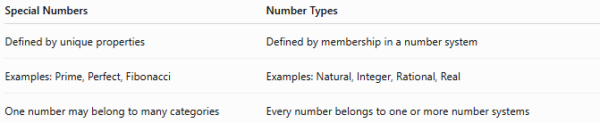
Special Numbers | Number Types
Defined by unique properties | Defined by membership in a number system
Examples: Prime, Perfect, Fibonacci | Examples: Natural, Integer, Rational, Real
One number may belong to many categories | Every number belongs to one or more number systems

Special Numbers vs. Mathematical Constants
# Source: AI Source: Provided by: [Data Path: Persons Table -> ID Column: 1, Name_En Column: Motasem Essam] -> From: [ChatGPT] on [7/11/2026]
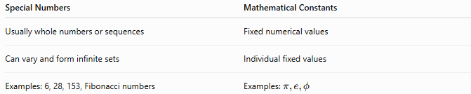
Special Numbers | Mathematical Constants
Usually whole numbers or sequences | Fixed numerical values
Can vary and form infinite sets | Individual fixed values
Examples: 6, 28, 153, Fibonacci numbers | Examples: $π,e,ϕ$

Special Numbers vs. Sequences
# Source: AI Source: Provided by: [Data Path: Persons Table -> ID Column: 1, Name_En Column: Motasem Essam] -> From: [ChatGPT] on [7/11/2026]
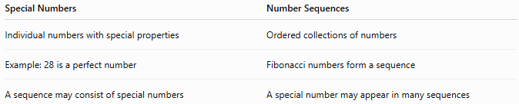
Special Numbers | Number Sequences
Individual numbers with special properties | Ordered collections of numbers
Example: 28 is a perfect number | Fibonacci numbers form a sequence
A sequence may consist of special numbers | A special number may appear in many sequences

Conclusion
# Source: AI Source: Provided by: [Data Path: Persons Table -> ID Column: 1, Name_En Column: Motasem Essam] -> From: [ChatGPT] on [7/11/2026]
Special Numbers are numbers that possess distinct mathematical properties or belong to recognized mathematical classifications. Examples include prime numbers, perfect numbers, square numbers, Fibonacci numbers, Armstrong numbers, and palindromic numbers. These numbers are fundamental to number theory and have numerous applications in mathematics, computer science, cryptography, engineering, and scientific research. Studying special numbers helps reveal the rich structure, patterns, and relationships within the world of mathematics.

